**Post-Secondary Transcripts Package**

Gordon Stevens

Contents

Websites which explain post-secondary credentials in Ontario, Canada 2

Completed Education 2

Ongoing Education 2

Unofficial Loyalist College Transcript 3

Unofficial Centennial College Transcript 8

Unofficial Seneca College Transcript 12

Unofficial Cape Breton University Transcript 14

# Websites which explain post-secondary credentials in Ontario, Canada

Ontario Qualifications Framework (Official): <http://www.tcu.gov.on.ca/pepg/programs/oqf/>

Post-Secondary Credentials in Ontario: <https://oncat.ca/en/postsecondary-credentials-ontario>

# Completed Education

**Loyalist College**

Program Website: <https://www.loyalistcollege.com/programs-and-courses/full-time-programs/chemical-engineering-technician/>

Chemical Laboratory Assistant (2010): Ontario College Certificate (Level 5 Certificate III)

Chemical Engineering Technician (2011): Ontario College Diploma (Level 7 Diploma II)

Chemical Engineering Technologist (2012): Ontario College Advanced Diploma (Level 8 Advanced Diploma)

**Centennial College**

Program Website: <https://www.centennialcollege.ca/programs-courses/full-time/software-engineering-technician/>

Software Engineering Technician (2017): Ontario College Diploma (Level 7 Diploma II)

# Ongoing Education

**Cape Breton University** (Sydney, Cape Breton, Nova Scotia, Canada)

Master of Business Administration (MBA) Degree in Community Economic Development (Equivalent to Ontario Level 12 Masters Degree)

Program Website: <https://www.cbu.ca/academics/programs/mba-in-community-economic-development/>

Notes: Cross-provincial funding was discontinued for this program and it is expensive. Currently not attending classes.

**Seneca College**

International Business Management (Ontario Graduate Certificate, Level 9 Post-Diploma Certificate)

Program Website: <https://www.senecacollege.ca/programs/fulltime/IBS.html>

Notes: Currently attending Semester 2 of 2.

# Unofficial Loyalist College Transcript

Official transcripts are only sent through mail directly from the college, the following is a screen-capture from the Loyalist College Banner Student System. Overall transcript GPA is listed on the last page of the screen-capture.

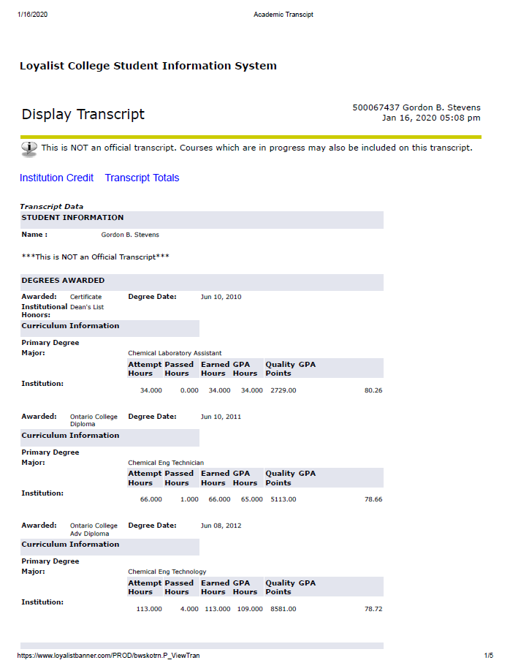

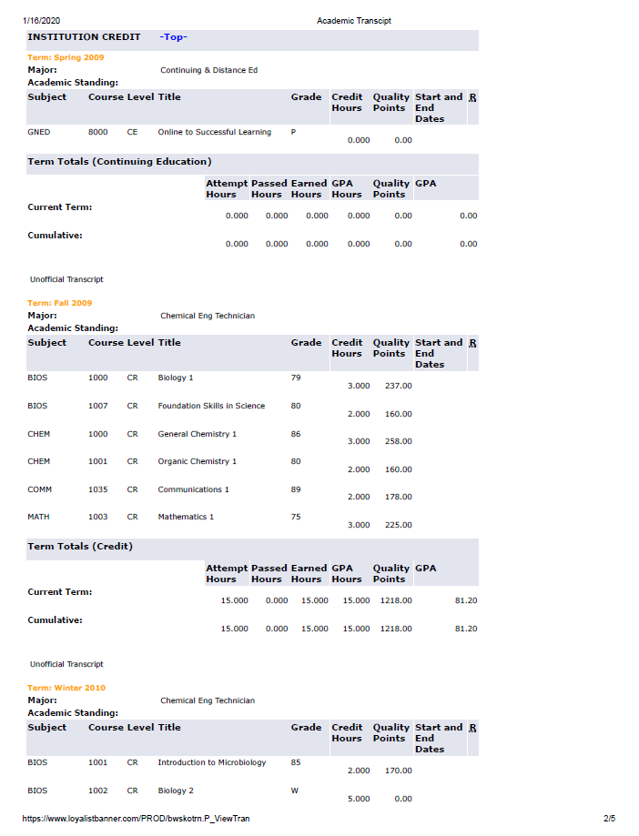

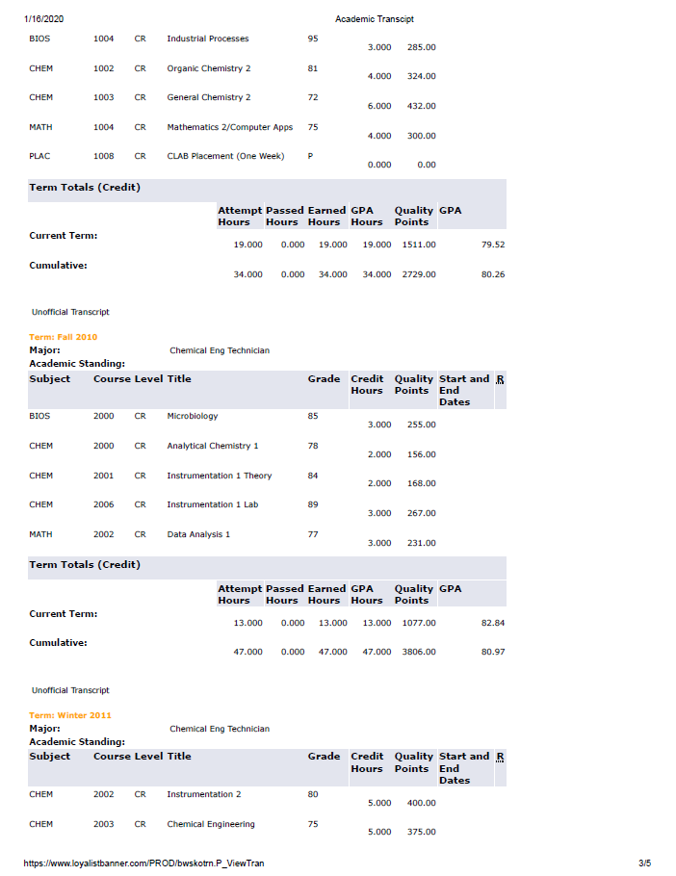

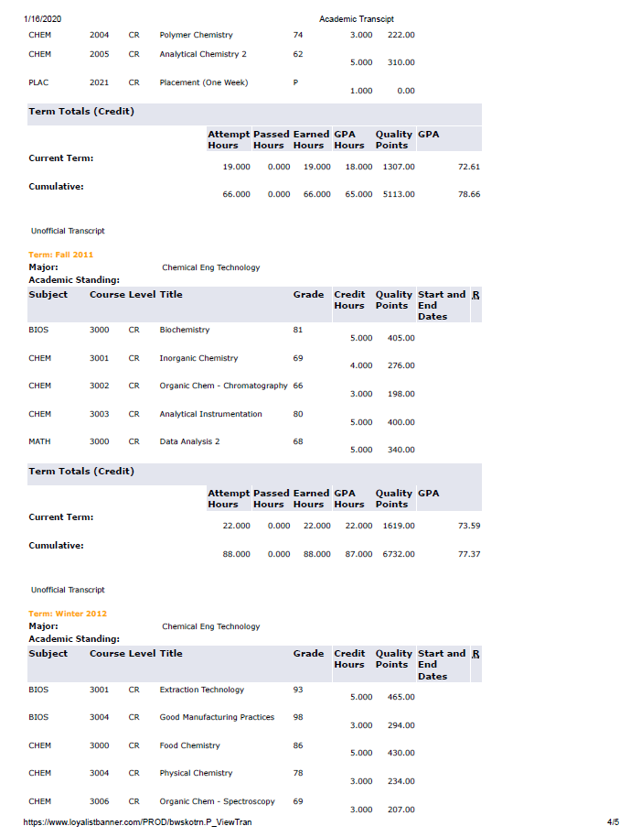

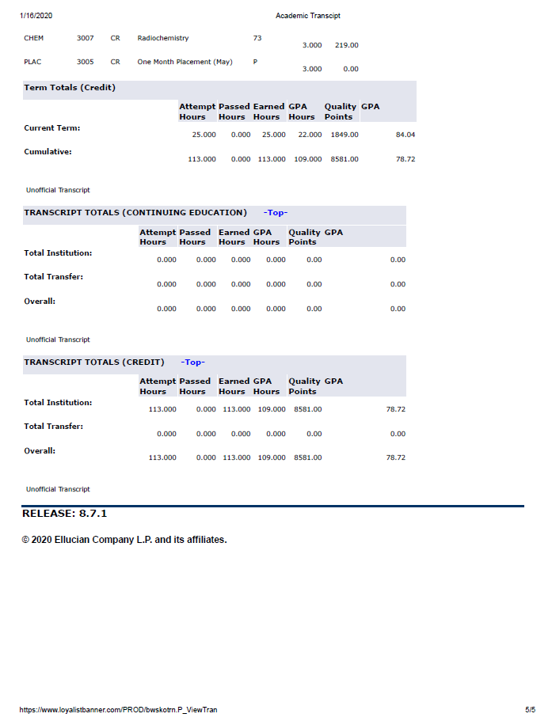

# Unofficial Centennial College Transcript

Official transcripts are only sent through mail directly from the college, the following is a screen-capture from the Centennial College Student System. Total Institution GPA is listed on the last page of the screen-capture.

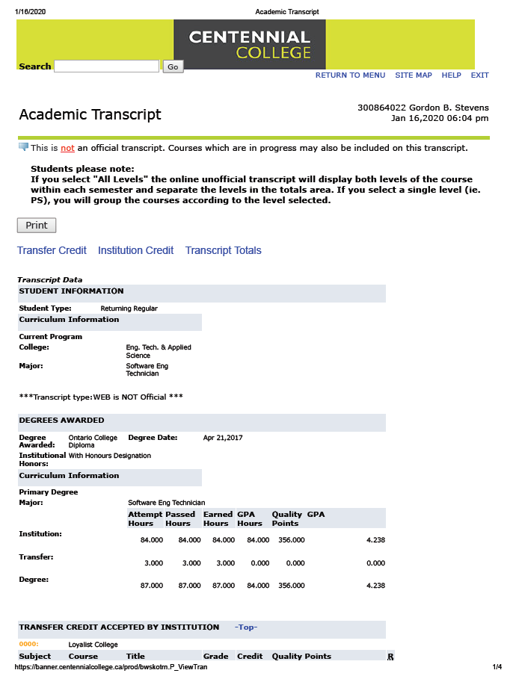

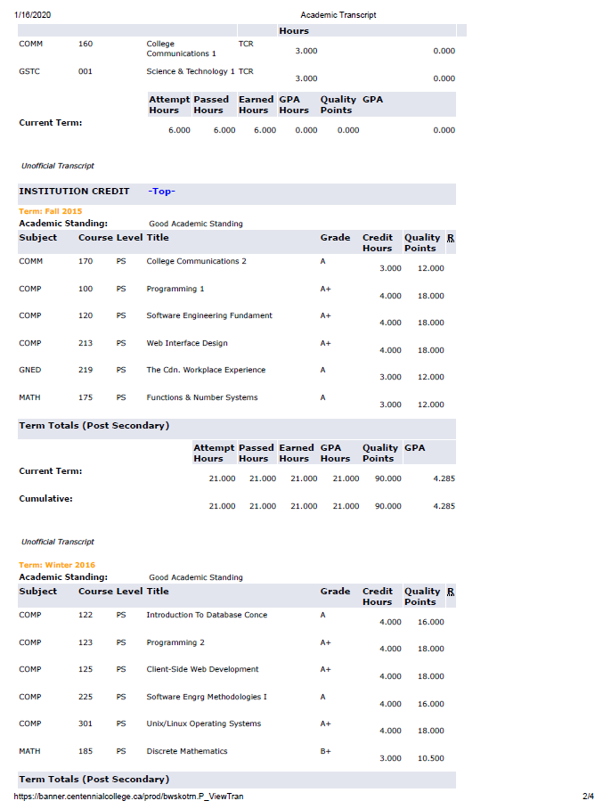

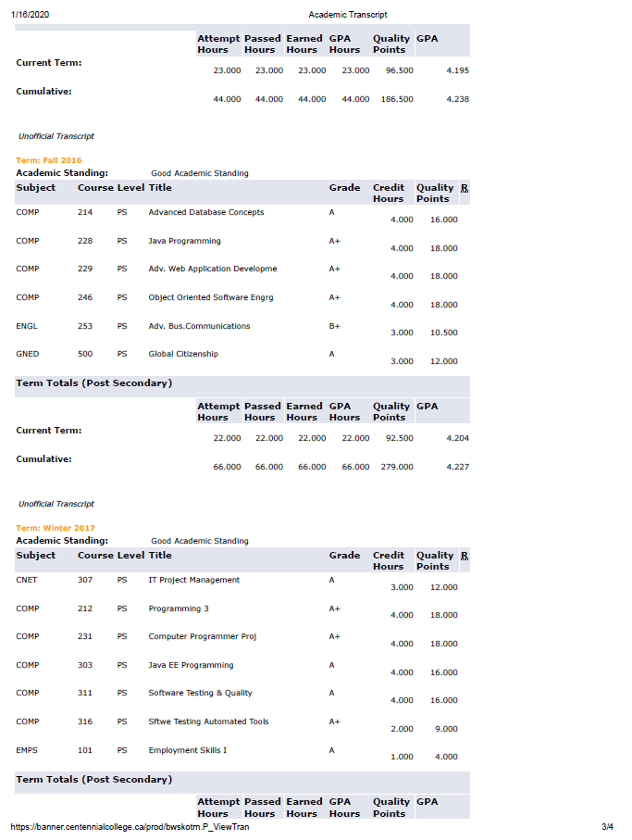

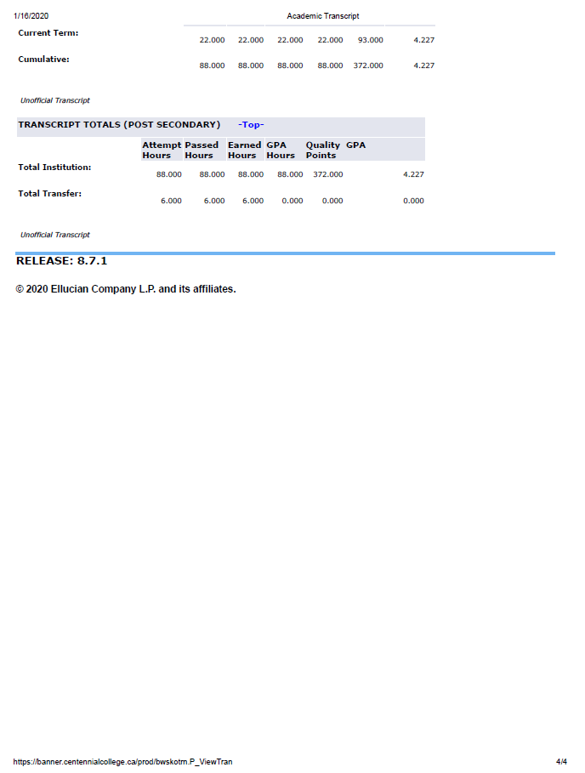

# Unofficial Seneca College Transcript

Official transcripts are only sent through mail directly from the college, the following is a screen-capture from the Seneca College Student System. Total Institution GPA is listed on the last page of the screen-capture.

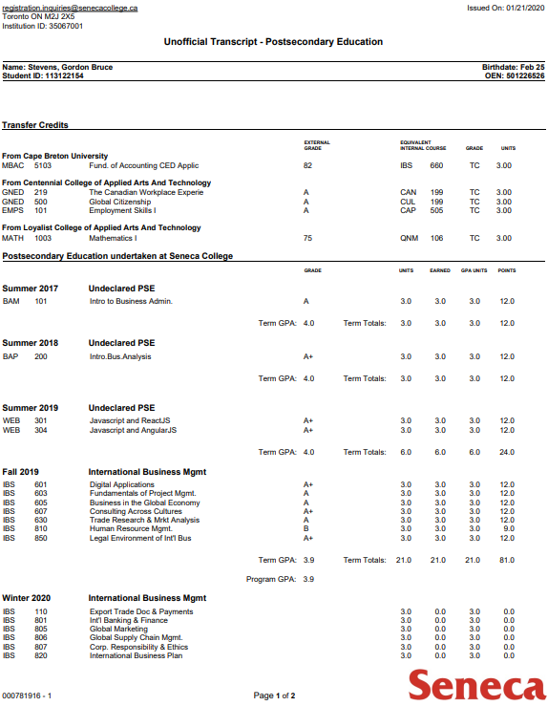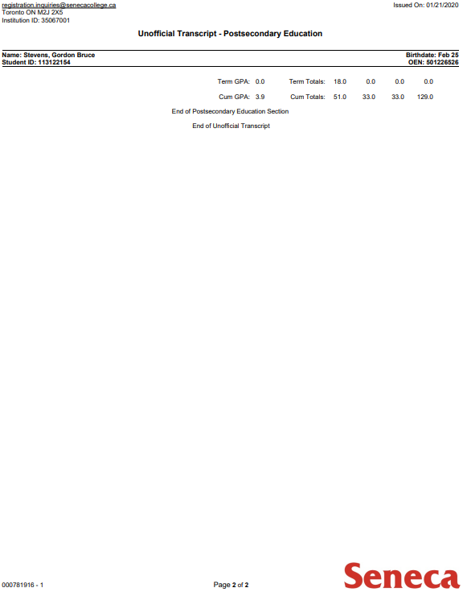

# Unofficial Cape Breton University Transcript

Official transcripts are only sent through mail directly from the university, the following is a screen-capture from the Cape Breton Student Porta System. Total Institution GPA is not defined, but final marks

